Operations, Technology & Management Plan

Contents
MANAGEMENT & ORGANIZATION 3
OPERATIONAL PLAN 4
TECHNOLOGY PLAN 5
REFERENCES 7

MANAGEMENT & ORGANIZATION
Green Hills
Alcohol is considered a legal in most of the countries where people are likely to drink in different cultures. In some parts of the world, alcohol is being illegal, and no n-alcoholic beverages are permitted to drink. Green Hills is one of the nonalcoholic beverage companies which provide drinks which do not contain any alcoholic substances. The management of Greenhill has to prepare a plan for enhancing the level of operations (Austin and Hust, 2005).
Below image demonstrates the structure of management in Green Hills Company. It helps to understand the deployment of employees in different sections of the firm.
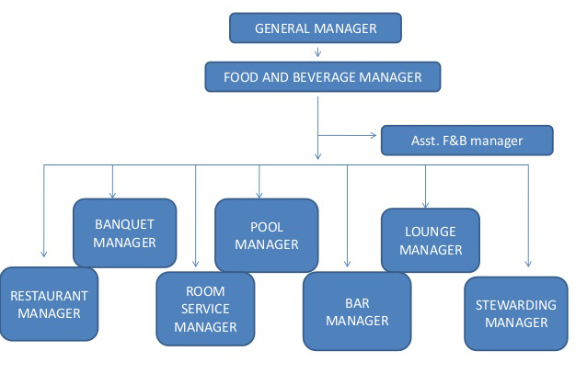
The above diagram demonstrates the hierarchy of Green Hills Company where in managers has been deployed in various sections of the company. There are different types of managers in the enterprise. The flow of information is from top to bottom wear in information flows from food and beverage manager to assistant food and beverage manager. Afterwards, the instructions pass to various individual managers like restaurant manager, banquet manager, room service manager, pool manager, bar manager, lounge manager and stewarding manager (Loria et al., 2010).

OPERATIONAL PLAN
The operational plan of Green Hills Company consists of actions that have to be taken in future business activities. This amount or quantity or quality of non-alcoholic beverages in Green Hills may get changed the world after a particular period. Thus, it becomes necessary to identify the outcomes through the current business Strategies and the acquired objectives.
Below is the operational plan of Green Hills Company which consists of various stages:
- Developing a concept of business: The main concept of Green Hills Company is to serve non-alcoholic beverages to customers. The core objective of a firm should be to identify that for competitive activities as well as to gauge the potential elements of factors that might provide the advantage to the firm regarding profitability (Fan and Cao, 2013). Green Hills might be facing use expenses to deliver services towards customers. Therefore, it can be ideal for the form to outsource services professional manners which might impact over the Goodwill of the firm. In such a case Green Hills have to concentrate our certain outsiders who can uplift the standard of business operations.
- Acquiring necessary information: Green Hills have to obtain information through conducting research is like survey questionnaire, interviews, or direct observations of customers and higher experts to analyze the results of the research (Bailey, 2014). This information plays a role in developing the operational plan in an ideal manner.
- Defining challenges: one of the most difficult challenges that are confronted by Green Hills is bearing of huge cost and expenses in different areas. Along with the focus on current challenges, it is necessary for Green Hills to concentrate over those achievements milestone which has to be achieved during 6 months or 12 months (Babor, 2009). This will help the form to set targets like actual position and the end position. Hence the difference between actual and estimated position will help to create plans and policies to achieve goals.
- Building plan: the last stage of the organizational plan indicates organizing of resources logical functional categories of operations management (Berger et al., 2011). This stage includes the fact best information regarding cost and time line and will also include certain technical methods which will be done through a lot of calculations.
- Thus the above plan of operations management in Green Hills Company will help the operations managers to accomplish their goals in the desired manner.

TECHNOLOGY PLAN
Green Hills Company has to achieve advancement in its level of services through adopting latest technological tools and technologies. This will assist the mentioned business organization in ascertaining crucial information regarding its external as well as the internal surrounding.
1. Evaluating the environment for making innovative use of Technology: The national In the modern era of Technology has been increasing so rapidly (Achi, 2005). Greenhill Company is such a business organizations which have to acknowledge the advancement in technology through which it can promote its nonalcoholic beverages. Use of liquor has been increased in huge quantity in most of the countries of the world resulting in various diseases like damage of liver or other health issues. This kind of crucial information has to be collected through upgraded technological tools by Green Hills company, and as a result, the management can decide areas to be targeted for promoting their non-alcoholic beverages (Ashurst, 2016).
2. Defining desired results: The Green Hill Company has to define the period within which the results or objectives should be achieved in a time span of 5 years or 10 years.
3. Identification of Technology is required to achieve objectives: The mentioned organization has to assess the amount of risk involved in the investment regarding the implementation of Technology because if the amount of risk is high, then Green Hills will have to wait before making a serious Investment Program (World Health Organization, 2011). On the other hand, if the nonalcoholic beverages company have to gain the competitive advantage over other beverage companies then it becomes necessary to step up and make the significant investment for adopting core technology for meeting the vision and focus of objectives.
4. Establishment of quantifiable feedback system to ascertain progress: Once the technology has been approved by the Green Hills Company for enhancing the standard of beverages, it becomes necessary to measure the effectiveness of the implemented technology regarding services as well as profitability (International Agency for Research on Cancer, 2010).
5. Monitoring: - The last stage of the technological plan involves the assessment of current state of the organization before implementing the plan. At this stage, it is necessary for the form to assess the availability of resources such as staff members, sufficient amount of capital to adopt new technology, the reliability of new technology, the experience level of staff members about the new technology, etc.

REFERENCES
Achi, O.K., 2005. The potential for upgrading traditional fermented foods through biotechnology. African Journal of Biotechnology, 4(5), pp.375-380.
Ashurst, P.R., 2016. Chemistry and technology of soft drinks and fruit juices. John Wiley & Sons.
Austin, E.W. and Hust, S.J., 2005. Targeting adolescents? The content and frequency of alcoholic and nonalcoholic beverage ads in magazine and video formats November 1999–April 2000. Journal of Health Communication, 10(8), pp.769-785.
Babor, T.F., 2009. Alcohol research and the alcoholic beverage industry: issues, concerns and conflicts of interest. Addiction, 104(s1), pp.34-47.
Bailey, S., 2014. A guide to the non-alcoholic beverage industry. [Online]. Available through: <http://marketrealist.com/2014/11/guide-non-alcoholic-beverage-industry/>. [Accessed on 8/9/2017]
Berger, L.K. and et. al., 2011. Sociodemographic correlates of energy drink consumption with and without alcohol: results of a community survey. Addictive behaviors, 36(5), pp.516-519.
Fan, J.G. and Cao, H.X., 2013. Role of diet and nutritional management in non‐alcoholic fatty liver disease. Journal of gastroenterology and hepatology, 28(S4), pp.81-87.
International Agency for Research on Cancer, 2010. Alcohol consumption and ethyl carbamate (Vol. 96). IARC Press, International Agency for Research on Cancer.
Loria, P. and et. al., 2010. Practice guidelines for the diagnosis and management of nonalcoholic fatty liver disease: A decalogue from the Italian Association for the Study of the Liver (AISF) Expert Committee. Digestive and Liver Disease, 42(4), pp.272-282.
World Health Organization, 2011. Global status report on alcohol and health. World Health Organization.

